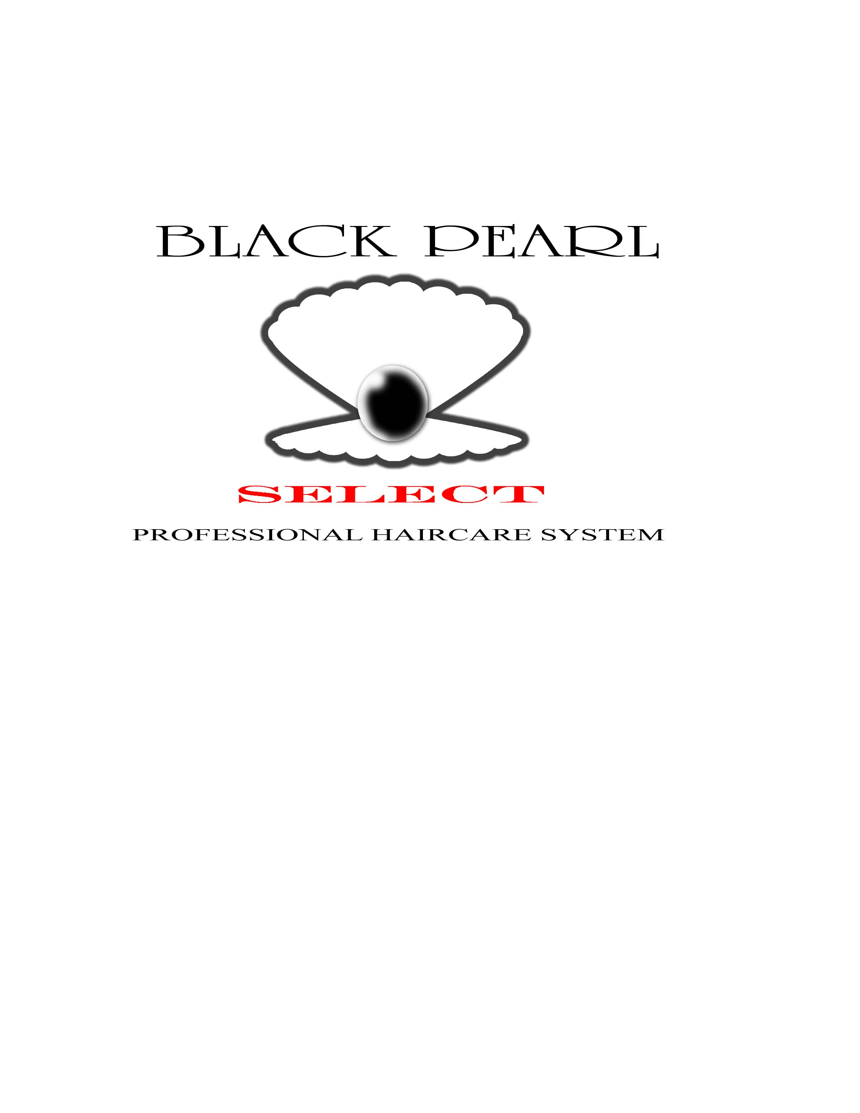

Salons & Products
along with
The Joe Johnson Foundation
Presents
Black Pearl's 5th Annual Comedy Luau
2009
July 11th
^{(Rain or Shine)}
Cahaba Shrine Park

Please contact Rachel Knight
(256) 489-1626

For more information, visit us online @ www.blackpearlselect.com
Special Thanks
to the
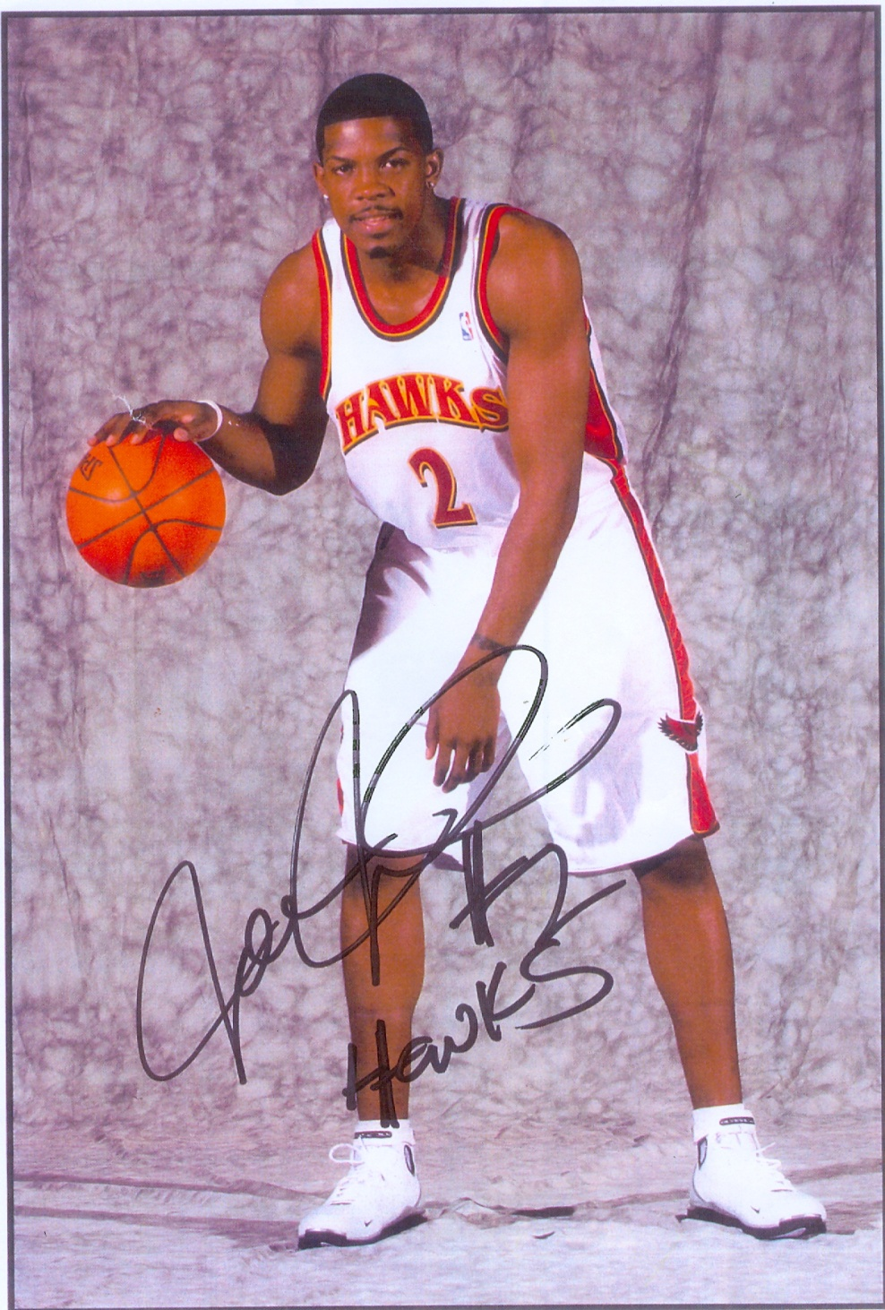

Joe Johnson Foundation
Come and join us on Saturday, July 11, 2009 at the 5th Annual Comedy Luau at Cahaba Shrine Park, 6001 Pulaski Pike, Huntsville, AL 35810. No alcohol allowed on premises.
This comedy luau is brought to you by Black Pearl Select Salons and Products, and The Joe Johnson Foundation.
We present to you this package in hopes of you becoming a sponsor for this anticipated event.

Let me tell you a little bit about the Luau…
There will be food, fun and entertainment for the entire family. We offer many fun filled events. A Comedy Fest featuring comics from all over. Some comics well known, and some from Huntsville. There will be music and entertainment to include local rappers (clean lyrics) and singers, karaoke and talent contest. A kid zone will be set up for all children including a play area, carnival rides, moon bounce, train rides and much more. We will also offer a cook off competition for all the grillers in the area. Our vendor booths include art, photos, V.F.P. Hair care products, Hawaiian trinkets, handbags and accessories, t-shirts, Pops World Famous BBQ Sauce, candles, incense, voter registration and much more.


The 5th Annual Comedy Luau
2009
Sponsorship Packages

- DiaMon
- Platinum
- Gold
- Silver
- Bronze

***Note***
Portions of the proceeds will be donated to the Muscular Dystrophy Association and other charity events such as “Free Community Cuts” for the kids on certain Holidays, and “Free Back to School Cuts”. All sponsored by Black Pearl Select Salons. If you are interested in renting a booth or sponsoring a ride, but not becoming a major sponsor, booth rental is $100.
DiaMon Sponsorship
$1000
Includes
- Booth
- 12 Meal Tickets
- Recognition:
On stage throughout the entire event
Name/logo on the stage banner
Name/logo on the Luau t-shirts
Radio, flyers and all promos
- Reserved Parking
- Sponsorship Plaque
--------------------------------------------------------------------------------------------------------------------------------------------------------

This sponsorship includes radio, banner, and t-shirt advertisement coverage. Please include company slogan and a camera ready logo image. Deadline for submissions and payment is Wednesday, July 8, 2009 (postmarked).
Sponsorship Level ____________________________________________________________
Company Name______________________________________________________________
Company Representative/Point of Contact________________________________________
Address____________________________________________________________________
Phone_____________________________________________________________________
Email_____________________________________________________________________
Amount enclosed $_____________
Camera Ready Logo Attached YES________NO_________
Make Check/Money Order Payable to: Black Pearl Select – Comedy Luau 2009
Complete this portion and mail to:
Black Pearl Select Salons
2908 Meridian Street, Suite A
Huntsville, AL 35811
An email confirmation will be sent upon receipt
PLEASE PRINT AND RETURN WITH SPONSORSHIP PAYMENT

Platinum Sponsorship
$750
Includes
- Booth
- 8 Meal Tickets
- Recognition:
On stage throughout the entire event
Name/logo on the stage banner
Name/logo on the Luau t-shirts
- Reserved Parking
- Sponsorship Plaque
--------------------------------------------------------------------------------------------------------------------------------------------------------

This sponsorship includes radio, banner, and t-shirt advertisement coverage. Please include company slogan and a camera ready logo image. Deadline for submissions and payment is Wednesday, July 8, 2009 (postmarked).
Sponsorship Level ____________________________________________________________
Company Name______________________________________________________________
Company Representative/Point of Contact________________________________________
Address____________________________________________________________________
Phone_____________________________________________________________________
Email_____________________________________________________________________
Amount enclosed $_____________
Camera Ready Logo Attached YES________NO_________
Make Check/Money Order Payable to: Black Pearl Select – Comedy Luau 2009
Complete this portion and mail to:
Black Pearl Select Salons
2908 Meridian Street, Suite A
Huntsville, AL 35811
An email confirmation will be sent upon receipt
PLEASE PRINT AND RETURN WITH SPONSORSHIP PAYMENT

Gold Sponsorship
$500
Includes
- Booth at discounted rate
- 5 Meal Tickets
- Recognition:
On stage throughout the entire event
Name/logo on the stage banner
- Reserved Parking
- Sponsorship Plaque
--------------------------------------------------------------------------------------------------------------------------------------------------------

This sponsorship includes banner advertisement coverage. Please include company camera ready logo image. Deadline for submissions and payment Wednesday, July 8, 2009 (postmarked).
Sponsorship Level ____________________________________________________________
Company Name______________________________________________________________
Company Representative/Point of Contact________________________________________
Address____________________________________________________________________
Phone_____________________________________________________________________
Email_____________________________________________________________________
Amount enclosed $_____________
Camera Ready Logo Attached YES________NO_________
Make Check/Money Order Payable to: Black Pearl Select – Comedy Luau 2009
Complete this portion and mail to:
Black Pearl Select Salons
2908 Meridian Street, Suite A
Huntsville, AL 35811
An email confirmation will be sent upon receipt
PLEASE PRINT AND RETURN WITH SPONSORSHIP PAYMENT

Silver Sponsorship
$250
Includes
- 3 Meal Tickets
- Recognition:
On stage throughout the entire event
Name/logo on the stage banner
- Reserved Parking
- Sponsorship Certificate
--------------------------------------------------------------------------------------------------------------------------------------------------------

This sponsorship includes banner advertisement coverage. Please include camera ready company logo image. Deadline for submissions and payment is Wednesday, July 8, 2009 (postmarked).
Sponsorship Level ____________________________________________________________
Company Name______________________________________________________________
Company Representative/Point of Contact________________________________________
Address____________________________________________________________________
Phone_____________________________________________________________________
Email_____________________________________________________________________
Amount enclosed $_____________
Camera Ready Logo Attached YES________NO_________

Make Check/Money Order Payable to: Black Pearl Select – Comedy Luau 2009
Complete this portion and mail to:
Black Pearl Select Salons
2908 Meridian Street, Suite A
Huntsville, AL 35811
An email confirmation will be sent upon receipt

PLEASE PRINT AND RETURN WITH SPONSORSHIP PAYMENT

Bronze Sponsorship
$100
Includes
- 2 Meal Tickets
- Recognition:
On stage throughout the entire event
- Reserved Parking
- Sponsorship Certificate
--------------------------------------------------------------------------------------------------------------------------------------------------------

Deadline for submissions and payment is Wednesday, July 8, 2009 (postmarked).

Sponsorship Level ____________________________________________________________
Company Name______________________________________________________________
Company Representative/Point of Contact________________________________________
Address____________________________________________________________________
Phone_____________________________________________________________________
Email_____________________________________________________________________
Amount enclosed $_____________
Camera Ready Logo Attached YES________NO_________
Make Check/Money Order Payable to: Black Pearl Select – Comedy Luau 2009
Complete this portion and mail to:
Black Pearl Select Salons
2908 Meridian Street, Suite A
Huntsville, AL 35811
An email confirmation will be sent upon receipt

PLEASE PRINT AND RETURN WITH SPONSORSHIP PAYMENT

